Ben Robinson

R020140g@student.staffs.ac.uk

Group Game Development Project and Work Based Simulation

Assessment

Contents

**No table of contents entries found.**

# Game Engine Analysis

## CSV Reading and writing

### Explaining CSV’s and what I did with them

Comma Separated Values (CSV) is a data structure commonly used within the software industry to move information between programs however is also used in the games industry to easily customise important data within the game. For the engine it was my primary goal to create a set of CSV readers to allow developers to customise data such as, dialogue, enemies, players and attacks the players can learn. Data can be customised with in either an Excel spreadsheet (See Appendix: 2) or in notepad (See Appendix: 3).

The CSV reader will take in two types of variable being String and Integer. Integers can be read into the file with no issues, only requiring the number to be read in between two commas and having the read in value turned into an Integer using the “stoi()” function from the std library. On the other hand, strings are far more difficult to read in due to some needing punctuation marks such as commas and speech marks but being unable to use them normally since they are both necessary for reading in CSV files. To allow these punctuation marks strings within the CSV require

# Solo Game Analysis

# Appendices

## Appendix 1: My Repo



## Appendix 2: Game Engine Repo (My branch)

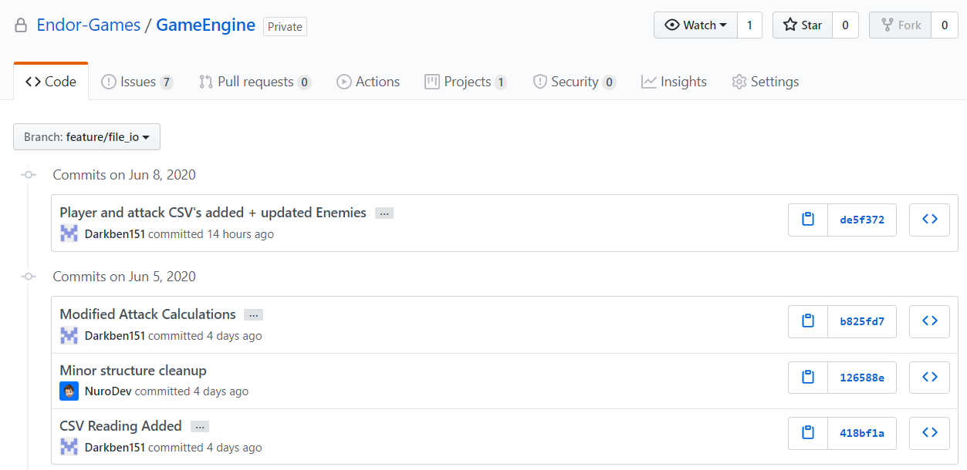

## Appendix 3: Example CSV’s in Excel

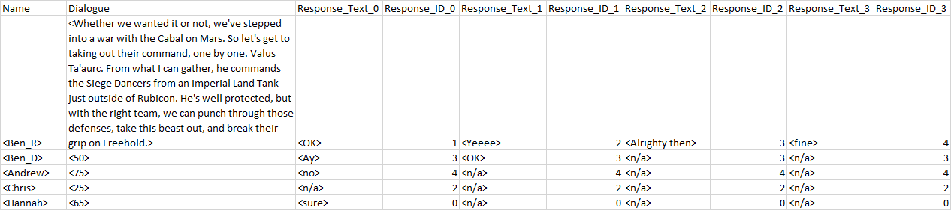

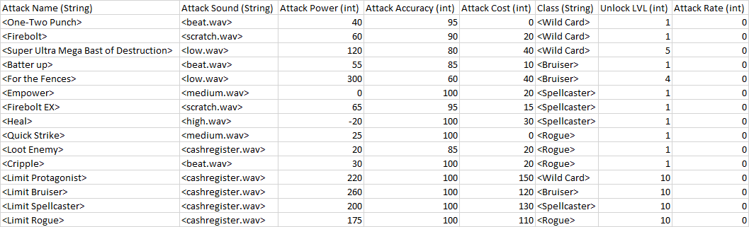

## Appendix 3: Example CSV’s in Text

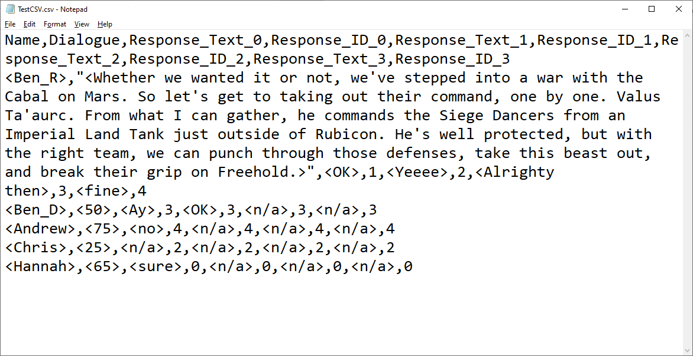

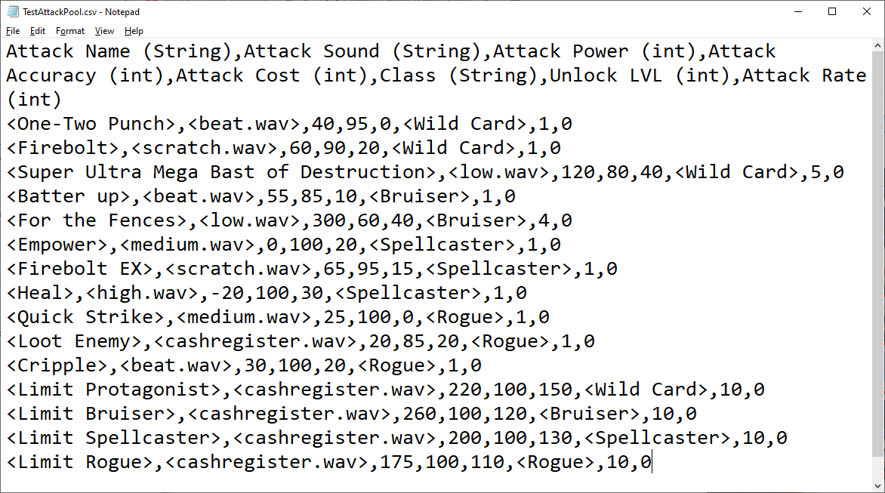

## Appendix 4: Failure to read commas in excel

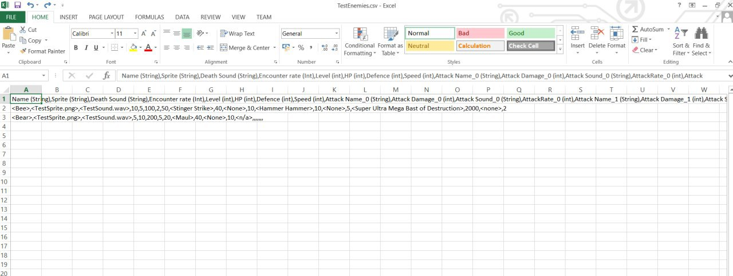

## Appendix 5: Code Snippets

### Appendix 5.1: Automatic integer reading

